**BADAM PEDE**

Special dish for Festive seasons, easy to cook, quick to prepare. Lil Kids, Specially for you. Prepare this for your Parents, friends and family on their special occasions. No flame required. So don’t be afraid. Just try it.



**Ingredients**:

* Coconut powder – 2 cup
* Milkmaid – 1 cup
* Almonds – ½ cup
* Cardamom powder – ¼ tsp

**Prep time :** 10 min

**Sepecial Equipment required:** Cookie Cutter

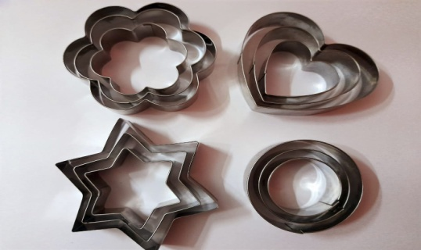

**Directions**:

* Take ¼ cup of Almond and grind it. Make a fine powder of it.
* Take a bowl. Add Coconut powder, Milkmaid, Cardamom powder and grinded Almonds into a bowl.
* Mix it very well.
* Now It will look like a dough.
* Choose any shape and size of cookie cutter . Add dough into cookie cutter and press it so that dough get shape as of cookie cutter.
* Now put half sliced Almond on it. And press it so that it get fix.
* Now push smoothly to get dough out of cookie cutter. Do it carefully. If you will push forcefully then it may spoil you shape. So do it carefully.
* Repeat the steps for rest of the dough.
* And Finally!! , your BADAM PEDE are ready. Enjoy it!!

